
Model: HPCS-18
1.5 HEAT PUMP
115V/1PH @ 20 Amps
The HPCS-18 Portable Heat Pump delivers dependable year-round climate control with a cooling capacity of 16,800 BTU and a heating capacity of 18,500 BTU. Designed for both cooling and heating applications, this versatile unit is an ideal solution for small offices, break rooms, hospital patient rooms, classrooms, and other indoor spaces that require temporary or supplemental temperature control. Its portable, self-contained design allows for quick and easy setup, providing comfortable heating or cooling within minutes without the need for costly or permanent installation. Whether you need additional cooling during warmer months or reliable heat when temperatures drop, the HPCS-18 offers a convenient and flexible solution.

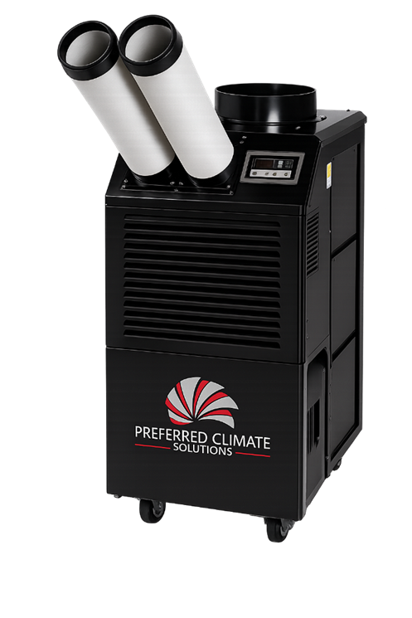
Features:
- Digitally Controlled Thermostat
- Built in Condensate Tank
- Two Speed Fan
- ETL Listed
 | BTU | VOLTS | AMPS | CURRENT CONSUMPTION | DIMENSIONS | WEIGHT
 | (Cool) 16,800 | 115V/1PH | 20 | (Cool) 15A | 20.6” x 26.4” x 41.1” | 189.6LBS
 | (Heat) 18,500 |  |  | (Heat) 15A

